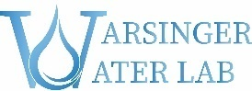
Project Team - Research Opportunities
Two intercollegiate project teams are being launched now, culminating in late Spring 2024. Participants will be in senior design courses (e.g. ME 463) or doing research credit (e.g. ME 498, BME 498, CHE 411). These have deliverables similar to such courses: final reports and presentations.
Projects Overview
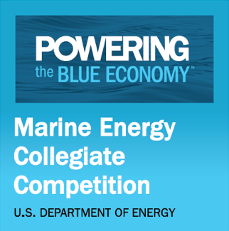
- Marine Energy Combined with Desalination: Marine energy has the potential to provide reliable power to the blue economy, but further work is needed to optimize designs and reduce costs. The competition’s objectives are to bring together diverse groups of students from multiple disciplines to explore opportunities for marine energy technologies to benefit other existing maritime industries via real-world concept development experiences. The Purdue teams have focused on combining wave power with desalination, since this is widely thought to have price competitiveness compared to waves to electricity. Purdue won 1st place in 2021’s competition, and 3rd place in 2023’s competition. Budget: ~$15k. More info: link

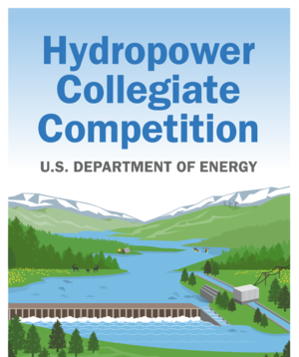
- Hydropower Collegiate Competition: Sponsored by DOE’s NREL, the HCC calls on interdisciplinary teams of undergraduate and graduate students from a variety of academic programs to offer unique solutions to complex hydropower challenges. The 2024 Hydropower Collegiate Competition asks multidisciplinary teams to develop solutions to add power-generating infrastructure to existing non-powered dams. We will work with a partner university for the siting and community connection challenges, with design and build-test being an emphasis at Purdue. Teams will analyze how hydropower fits into a future power grid supported by 100% renewable energy. Budget: ~$10k. More info: link

Both teams will get to compete in DC after finals week.
Interests/Qualifications: Applicants should have an interest in energy, water science, and sustainability. Preferred applicants have experience in any of the following: experiment design, rapid prototyping, manufacturing, Python, LabView, EES, MATLAB, 3D CAD, & Adobe Illustrator.
What experience will you gain?
- Hands on research experience and potential co-authorship in high impact journals
- Research credit hours (and potential opportunities for financial compensation in the summer)
- Networking opportunities with start-ups, academic collaborators, and industry leaders
If interested, please contact Imaan and Aaron (iqazilba@purdue.edu and amharp@purdue.edu) with your resume or questions.

